**Black Box Testing**

**Appliance Grabbability**

|  |  |  |
| --- | --- | --- |
| **test** | **expected** | **actual** |
| Attempt to grab an appliance in renovation mode | The appliance gets picked up | The appliance gets picked up |
| Attempt to grab an appliance in dining mode | The appliance does not get picked up | The appliance does not get picked up |

**Hob Appliance**

|  |  |  |
| --- | --- | --- |
| **test** | **expected** | **actual** |
| Place raw meat on the hob and wait for the progress bar to fill up | The raw meat become rare meat and the progress bar resets | The raw meat become rare meat and the progress bar resets |
| Place well done meat on the hob | No progress bar appears | No progress bar appears |
| Place plate on the hob | No progress bar appears | No progress bar appears |
| Place raw meat on the hob and wait for the progress bar to fill up twice | The raw meat become rare meat and the progress bar resets. When it fills again, the rare meat become medium meat and the progress bar resets | The raw meat become rare meat and the progress bar resets. When it fills again, the rare meat become medium meat and the progress bar resets |

**White Box Testing**

**Hob Appliance**

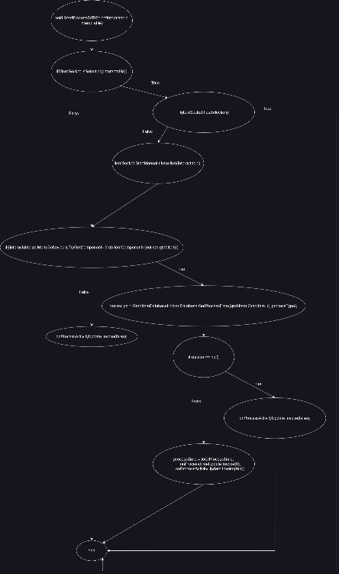

|  |  |  |
| --- | --- | --- |
| **test** | **expected** | **actual** |
| Try put meat on hob while a meat is already on hob | Nothing happens | Impossible to do in game |
| Start a process without placing the meat on the hob | Meat is automatically moved to the hob | Impossible to do in game |
| Place fully cooked meat on hob | Nothing happens | Nothing happens |
| Place plate on the hob | Nothing happens | Nothing happens |

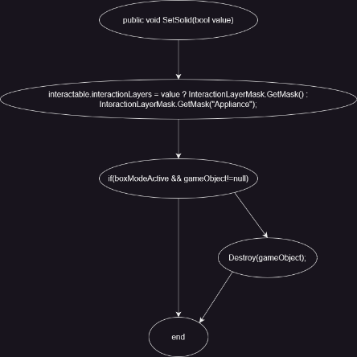

|  |  |  |
| --- | --- | --- |
| **test** | **expected** | **actual** |
| Start work day | Appliances become ungrabbable, and any that are in a box are destroyed | Appliances become ungrabbable, and any that are in a box are destroyed |